**Career Plan Template**

**Format: Font: Verdana 12**

1. **Draw your road map or your career plan in five years (30%)**

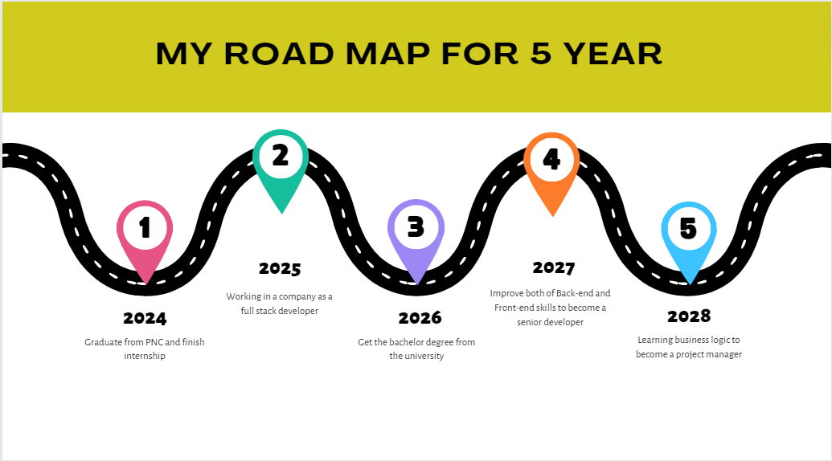

1. **Write reports with guidance questions (65%)**

|  |
| --- |
| 1. What is your professional goal in five years? 15% |
| I am going to have a good job with a good salary so that I can support my family and finish university. After graduating from PNC. |
| 1. What are your strengths and weaknesses? 10% |
| My strength: I can learn and do many subjects at the same time and I can do it well.  My weakness: I cannot make good communication with other people. |
| 1. What kind of company do you want to work for? And why? 10% |
| The kind of company that I want to work for is a Solution company. The reason that I want to work for a solution company is I can improve my skills much more than a Bank company however, It can be difficult for me, but I am still happy about that. |
| 1. How do you plan to upgrade yourself after PNC? 10% |
| The plan that I want to upgrade myself after PNC is to support my family, and improve my skills.  Support my family: I will help my parent to have a good house.  Improve hard skills: I will learn more programming languages that the job market needs.  Soft skills: I will improve my lack of points to make it easy to adapt in social and can make it easy to improve my job position. |
| 1. What do you think about how the future of the IT job market evolves in Cambodia? 10% |
| I think the IT job market will improve and people will have more opportunities related to IT because our country is developing now so the IT sector will keep improving. |
| 1. How do you adapt yourself to the evolving IT job market? 10% |
| To adapt myself to the evolving IT job market I will:   * Learning the new programing language * Learning back-end framework * Learning a short course on the internet to improve the lack point * Keep learning the programming language that the job market needs. |

1. Attach one JD of your ideal job (5%)

**Back-end developer**

**Technical Skills:**

1. Proficiency in front-end technologies such as HTML5, CSS3, JavaScript (ES6+), and modern JavaScript libraries/frameworks like React.js, Angular, or Vue.js.
2. Strong understanding of server-side programming languages such as Node.js, Python, Ruby, Java, or PHP.
3. Experience with back-end frameworks such as Express.js (for Node.js), Django (for Python), Ruby on Rails (for Ruby), Spring Boot (for Java), or Laravel (for PHP).
4. Knowledge of database management systems, both relational databases (e.g., MySQL, PostgreSQL) and NoSQL databases (e.g., MongoDB, Redis).
5. Proficiency in RESTful API design and development.
6. Experience with version control systems, such as Git.
7. Familiarity with DevOps practices and tools, including containerization (Docker, Kubernetes), continuous integration/continuous deployment (CI/CD), and cloud platforms (AWS, Azure, Google Cloud Platform).
8. Understanding of web security best practices and common vulnerabilities.
9. Knowledge of Agile development methodologies.
10. Experience with testing frameworks and methodologies, including unit testing, integration testing, and end-to-end testing.

**Experience:**

1. Previous experience (typically 2+ years) working as a Full Stack Developer or in a similar role.
2. Demonstrated experience in designing and developing web applications from scratch to deployment.
3. Experience collaborating with cross-functional teams, including designers, product managers, and other developers.
4. Experience with both front-end and back-end development tasks, including UI/UX design, server-side logic implementation, and database management.
5. Experience with troubleshooting and debugging complex web applications.

**Soft Skills:**

1. Strong problem-solving skills and a proactive attitude towards addressing technical challenges.
2. Excellent communication skills, both verbal and written, with the ability to convey technical concepts to non-technical stakeholders.
3. Adaptability and willingness to learn new technologies and frameworks.
4. Ability to work both independently and collaboratively in a fast-paced environment.
5. Attention to detail and a commitment to producing high-quality code.
6. Time management and organizational skills to prioritize tasks effectively.
7. Team player mentality with a positive attitude towards collaboration and knowledge sharing.